Mounting the new Keypad on the “Garmin Oregon 600-600T-650-650T ;
Read the instructions first before you start.

! Doing this is on your reasonability !

Required material ;
*Heat gun / Hot Hairdryer
*Acetone
*Acetoxy silicone sealant
*Scotts brite
*sharp knife / scissors
*Clean Cloth

1*Make a cut with a sharp knife on the Top and Bottom side,be sure you cut a shorter distance than the new keypad long is.
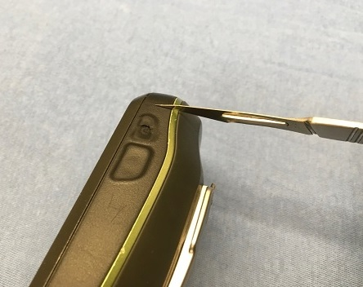

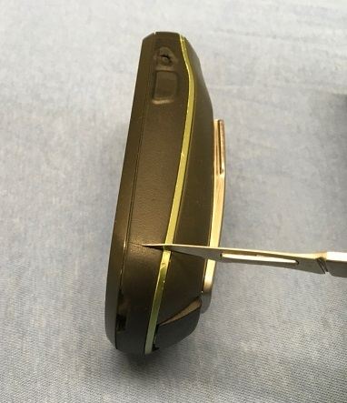
2* With a heat gun or hairdryer heat the rubber keypad and remove it , make it not too hot otherwise the casing will deform. Be sure you clean the small hole and the long edge also ( see two Red Arrows )

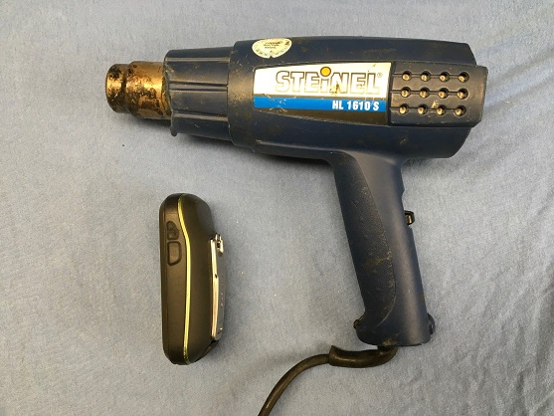

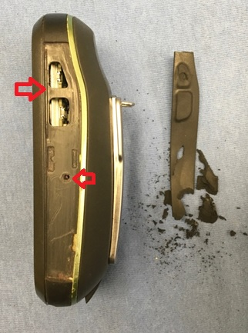

3*Remove the excess rubber residue with scotts brite,be careful that you don’t
scratch/damage the housing.

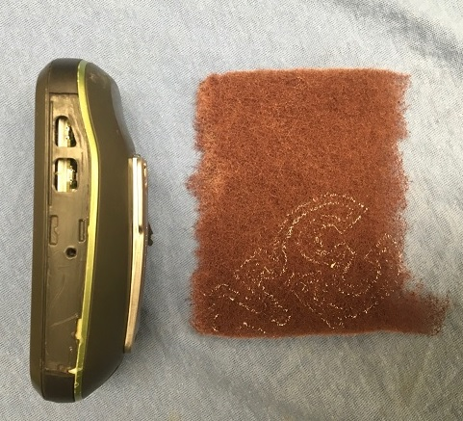

4* Place the new keypad rubber on the side of the Oregon and cut the excess top and bottom rubber away with a scissors to make it the correct length

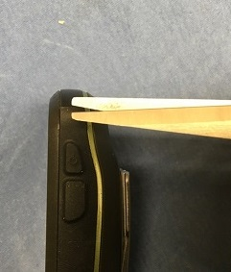

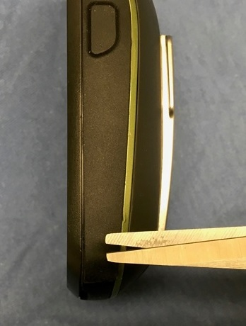

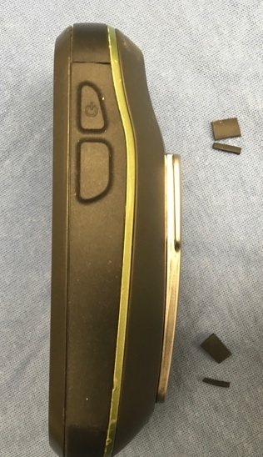

5* Degrease the surface with Acetone,be careful with the Acetone on the housing.

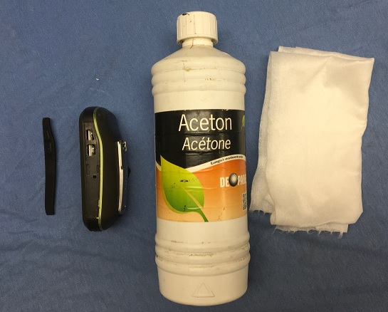

6* Use a silicone sealant on Acetoxy acid basis for gluing (smells like vinegar).
I believe in the States they selling for example, Sil Net™ Silicone Seam Sealer

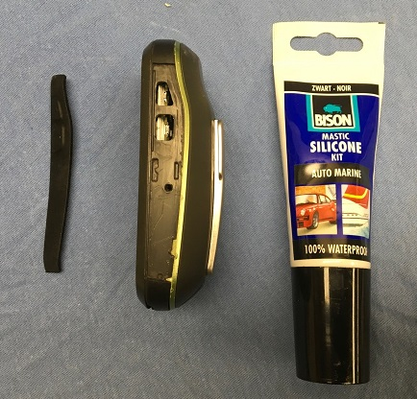

7* Ensure that the silicone sealant is at room temperature and not out of date.
Coat the surface of the rubber housing with the silicone sealant and around de edges.
Be sure you also put also the sealant into the small edge (see red Arrow)
Allow it to dry for +/- 3 to 4 minutes before you glue the new keypad on the housing.

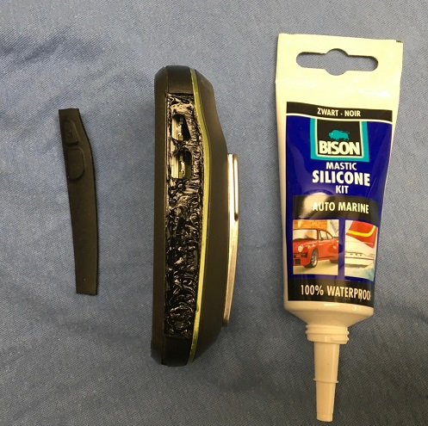
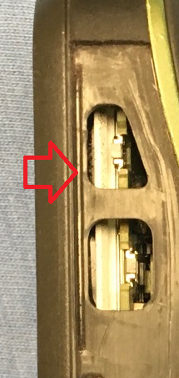

8* Put the small pin on the rubber keypad in the hole from the Oregon housing.
Press the rubber keypad well onto the housing,
remove the excess sealant that is coming out around the edges.

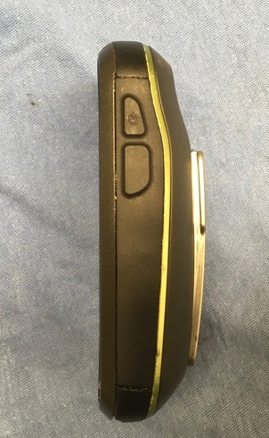

9* Press it firmly onto the housing

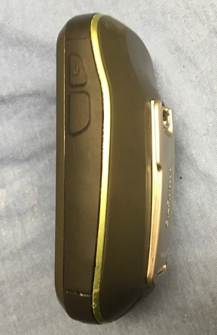

10* Leave the housing 24 hours at room temperature to dry for good adhesion .

